FROM A SINGLE SOURCE

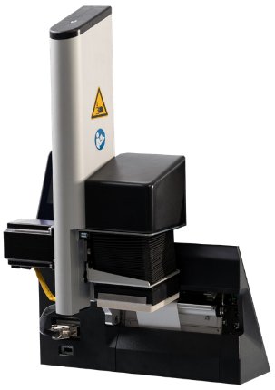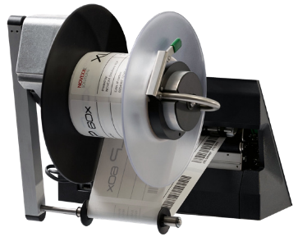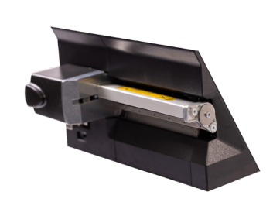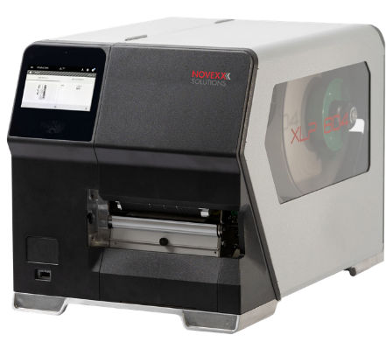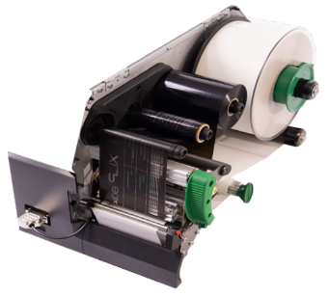

YOUR PERFECT FIT ...

DISPENSER & INTERNAL REWINDER

This solution prints and dispenses. The internal rewinder collects the backing paper automatically inside the XLP 60x and the

dispensed labels can be applied to the product manually or by an applicator.

EXTERNAL REWINDER

The external rewinder collects the printed labels onto a core. This roll of printed labels can be easily removed and installed in any labeling system, such as the XLS 2xx, for further processing.

LTMA

LIGHT TOUCH APPLICATOR

In combination with the Light Touch Applicator, the XLP 60x becomes a semi-automtic print & apply solution. The electrical, air pressure free applicator applies labels smooth to any surfaces and product heights.

CUTTER

The industrial rotary knife is easy to mount to the XLP 60x and delivers straight cut of labels after each single label or after a batch of printed labels.

SO MANY OPTIONS

Your application – our solution!

# Hardware, software and service from a single source – for best results

NOVEXX Solutions is a dynamic, globally operating medium-sized company with more than 55 years of experience in the labeling industry. As a specialist, we offer first-class identification and labeling solutions for products, cartons and pallets that promise to optimize the production and supply chain. Our portfolio includes powerful hardware, intelligent data management software, high-quality consumables and comprehensive service & support. 100% MADE IN GERMANY.

Our mission is to connect products with labels to strengthen the brand, increase productivity and reduce costs. We know the requirements of our customers – from medium-sized companies to global corporations.

NOVEXX Solutions is represented with 11 sites and more than 100 certified partners worldwide. We offer identification solutions that work!

Vimpan Solutions

Building No. 114, Block C,

Omicron II, Greater Noida,

Uttar Pradesh 201310

[www.vimpan.com](http://www.vimpan.com)

High performance hardware solutions

NOVEXX Solutions offers a wide portfolio of hardware solutions for labeling applications or variable data printing. In addition to Label Printers our identification solutions also include Print & Apply Systems, Labelers, Printing Systems and Plug & Play Complete Solutions – developed and manufactured in Germany.

High quality consumables

We offer a wide range of thermal transfer ribbons and self-produced labels, such as blank labels for variable data, labels with security features or full-color labels with individual designs. Our reliable consumables fit perfectly to the NOVEXX Solutions hardware.

We promise first-class print quality and perfect labels.

Data management software TRACE-it®

TRACE-it, the fully integrated software solution for central data and process management, completes the NOVEXX Solutions portfolio. The software supports companies in various industries in optimizing labeling and identification processes. No matter if they need to label individual products, containers, or entire pallets.

XLP

60x

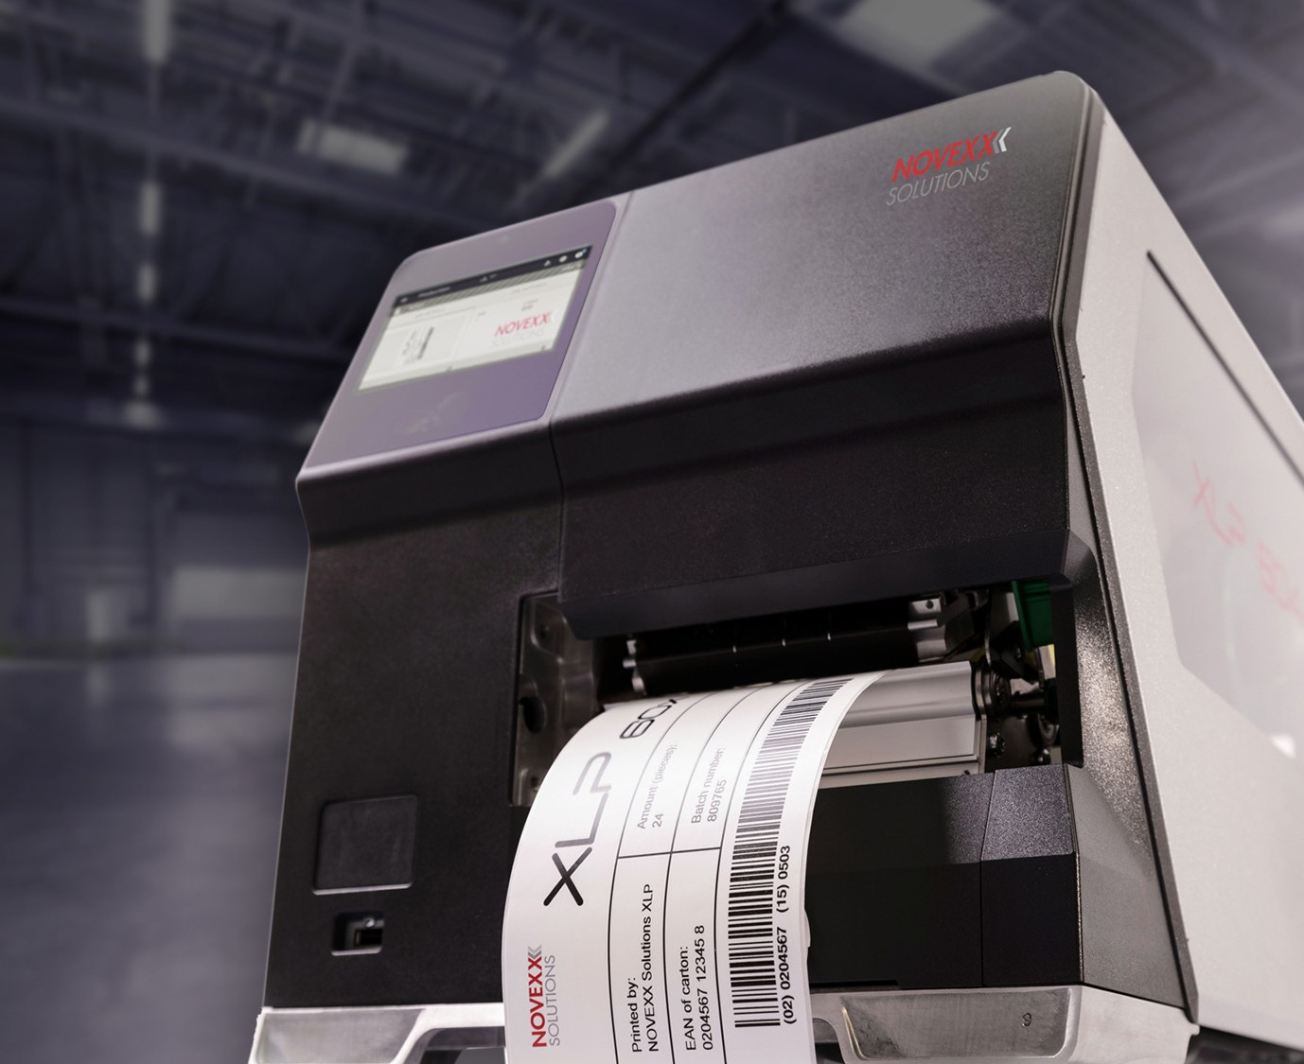

... if you need reliable, stress-free printing of your daily demand for printed labels.

... if you need high quality print results for important information on your labels,

like user and product information in pharma industry, health & safety information in the chemical industry or ingredients/allergies information in food industry.

... if you need labels in high volume and with real time data available instantly, like price & brand labels in garment industry, address labels in last-mile logistics or product labels in FMCG industries.

Seamless integration

NOVEXX Solutions experts support you during the integration process and beyond. We take the time to understand your processes and needs in detail so that we can offer the optimal solution for your business. We are always at your side – from finding the solution to integrating the system to maintenance and repair.

The information contained in this document is believed to be reliable, but NOVEXX Solutions makes no representations as to the accuracy or correctness of the data. As with all other data, this information should be independently validated with regard to the specific end-user conditions in order to ensure that the recommended identification solution complies with the relevant requirements and regulations.

©2021 Novexx Solutions GmbH, all rights reserved. Any trademarks and/or trade names of third parties used in these materials are the property of their respective owners.

www.vimpan.com

# INDUSTRIAL LABEL PRINTING IN PERFECTION

* Excellent print quality
* Highest productivity
* Maximum user-friendliness
* Intelligent printing
* Configurable printer options



2f.EN.DIR.1121.V01

LABEL PRINTING WITHOUT LIMITATIONS

The XLP 60x high-performance label printer is your perfect fit for any industrial printing challenge. The printer impresses with its exceptional print rate and excellent print quality.

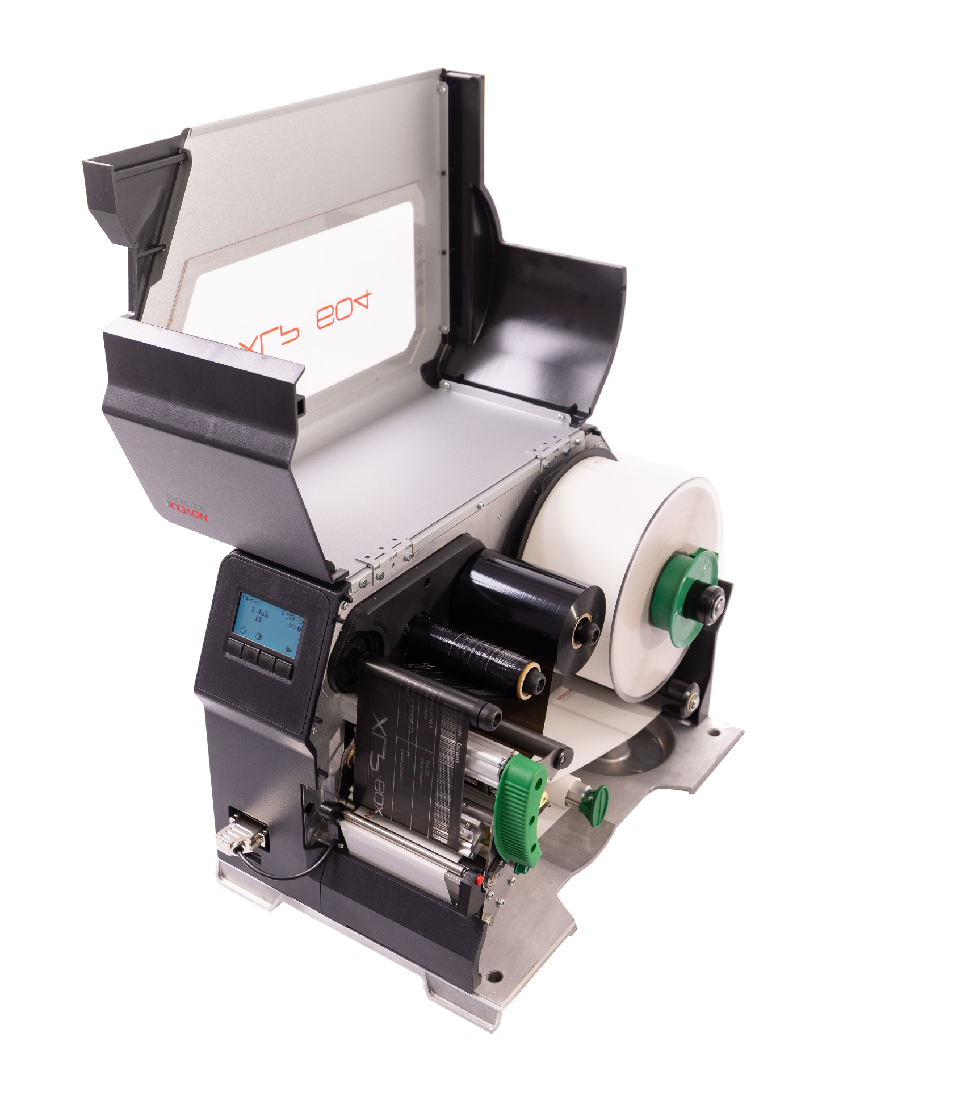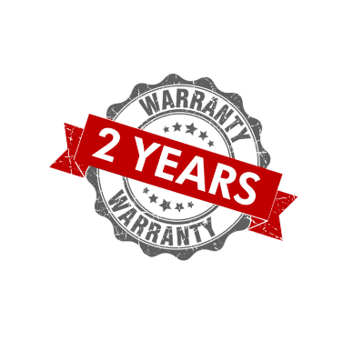

The choice of two different displays, numerous options and several configurable interfaces allows you to create the perfect label printer for your demand.

## MAXIMUM UPTIME

* Easy loading of the label and ribbon material
* Ribbon roll capacity up to 600 m length
* Large window to keep an overview of label and ribbon roll filling level

## TOUCHSCREEN

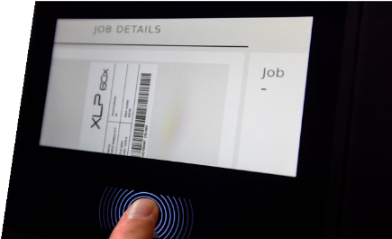

* + High-resolution full-color touchscreen
  + Maximum user-friendliness with functions like label preview
  + Web interface navigation
  + Usable with gloves

## ROBUST AND DURABLE

* + High-quality product components such as robust housing with sturdy metal frame
  + State of the art electrical components
  + Long lifetime guarantee

## INDUSTRIAL 4-KEY DISPLAY

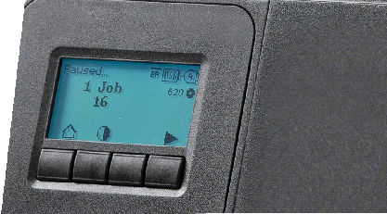

* + Large display with color backlighting
  + Intuitive, icon-guided navigation
  + Perfect for industrial environments
  + Recommended for heavy use

## EASY & CONVENIENT MAINTENANCE AND CLEANING

* + Open print module for easy cleaning
  + 100% tool-free maintenance
  + 100% tool-free replacement of wear parts

## EXCELLENT PRINT PERFORMANCE

* Excellent print quality
* Thermal transfer or thermal direct printing with 300 dpi print resolution
* Extraordinary print output per minute
* Extremely fast response time
* Easy-to-use ribbon mandrels to ensure stable ribbon tension for optimal print results

## AUTOMATIC SETTINGS

* Smart continuous ribbon tension for excellent print results
* Automatic setting of print head parameters such as pressure and contrast

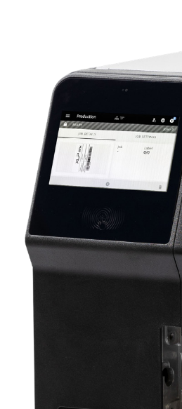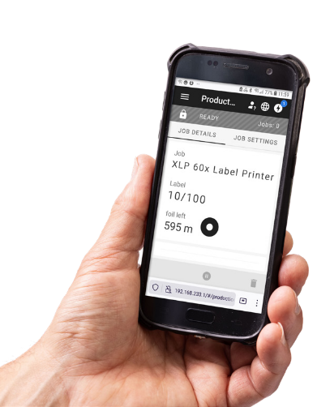

BENEFITS OF THE XLP 60X

EXCELLENT PRINT PERFORMANCE

XLP 60x delivers first-class print quality at high print speeds of up to 16” (400 mm) per sec.

MAXIMUM USER-FRIENDLINESS

Intuitive navigation, quick and convenient change of label and ribbon material.

MAXIMUM UPTIME

The industrial robustness

of the XLP 60x together with 100% tool-free maintenance and large ribbon capacity ensure maximum uptime and increased productivity.

CUSTOMIZED PRINTING

Thanks to the choice of two different displays, various options and several configurable interfaces, you can create together the perfect label printer for your requirements.

INCREASED SUSTAINABILITY

The Ribbon Save Function ensures that only the ribbon needed for printing is used. The result is less waste and chemicals as well as lower costs.

INTELLIGENT PRINTING

The XLP 60x meets the newest digital requirements: The web interface enables remote access and configuration from any PC or via mobile devices, such as smartphones and tablets. Optional interface boards deliver multiple I/O interfaces for any kind of automized application.

* Remote access and configuration via web interface
* Remote setup, diagnostics and maintenance
* All print jobs can also be followed remotely via the web interface
* Multiple I/O interfaces for use in an automated environment or a complex data environment
* Cross-media provision of information by connection via LAN inter-face, access to online remote support via QR code and wireless 1:1 connection with USB stick, including real time data retrieval and error messages
* Maximum flexibility and user-friendliness
* MQTT protocol to retrieve printer data and parameters

## FOR 4“ AND 5“/6“ PRINT WIDTHS

* + For all requirements: The XLP 60x is available in

4” (106 mm), 5” (127 mm), and 6” (160 mm) print widths

* + Perfect to print labels for products, cartons or pallets

picture: XLP 604 with dispenser & internal rewinder

## RIBBON SAVE FUNCTION

* + Optimized ribbon consumption
  + Reduced costs
  + Longer print head lifetime
  + More uptime
  + Protection of the environment: less waste & chemicals